**LABORATORY MANUAL**



for the complete fulfillment of the requirements for the lab course of

**Object Oriented Programming (OOP)**

Submitted by

**AADARSH MEHDI | 00314965**

Instructor

Mr. Rozi Khan

Lab Engineer, Department of Computer Science,  
National University of Sciences & Technology,   
Balochistan Campus (NBC), Quetta.

**Lab no 1:**

**Task 1:**

**Input:**

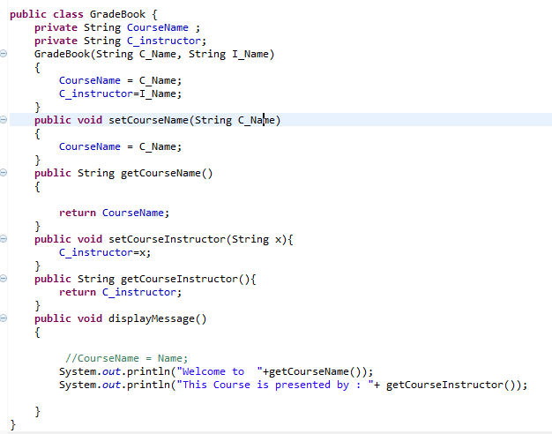

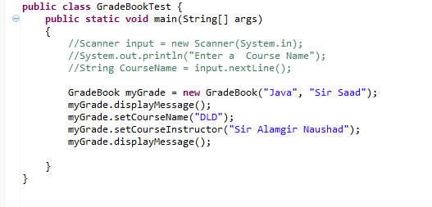

**Output:**

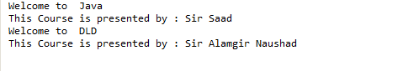

**Task 2:**

**Input:**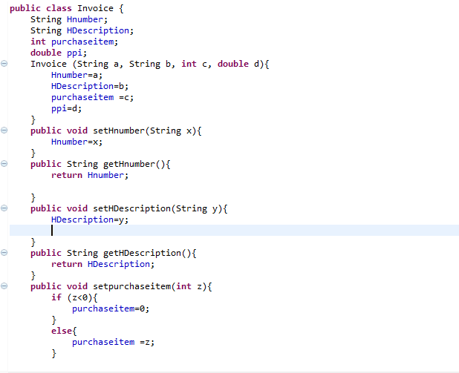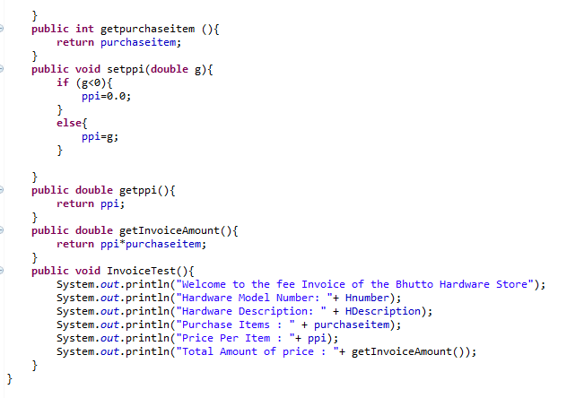

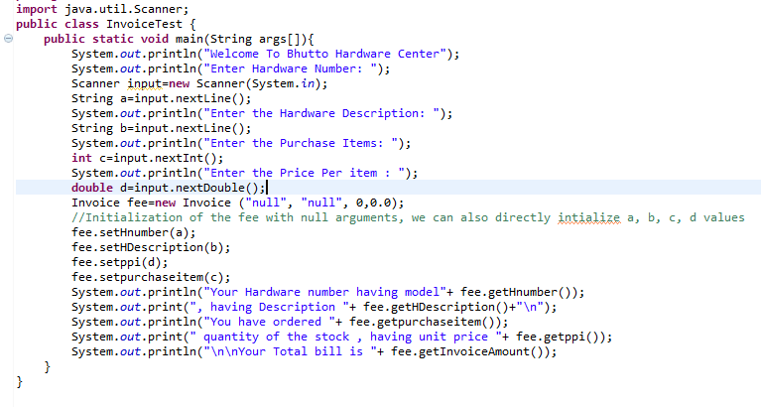

**Output:**

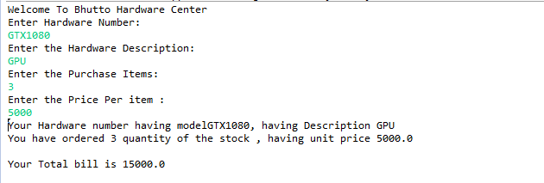

**Task 3:**

**Input:**

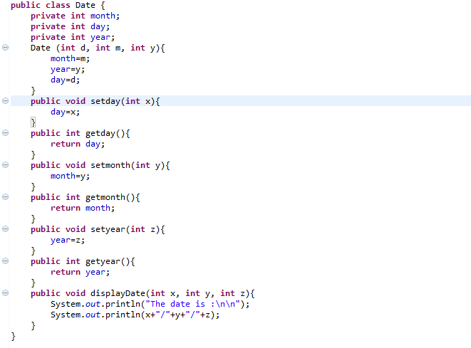**____________________________________________________**

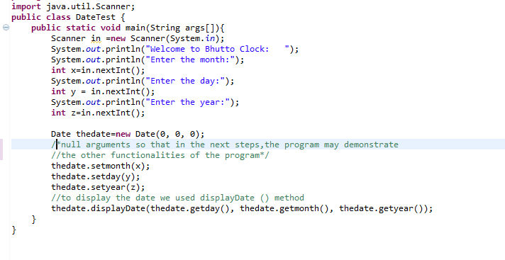

**Output:**

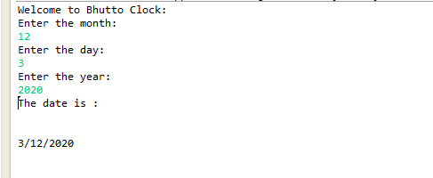

**Task 4:**

**Input:**

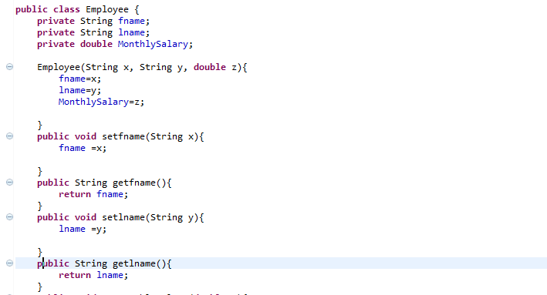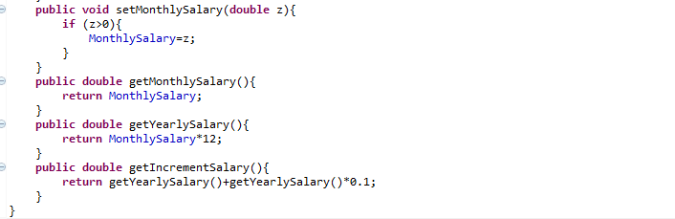

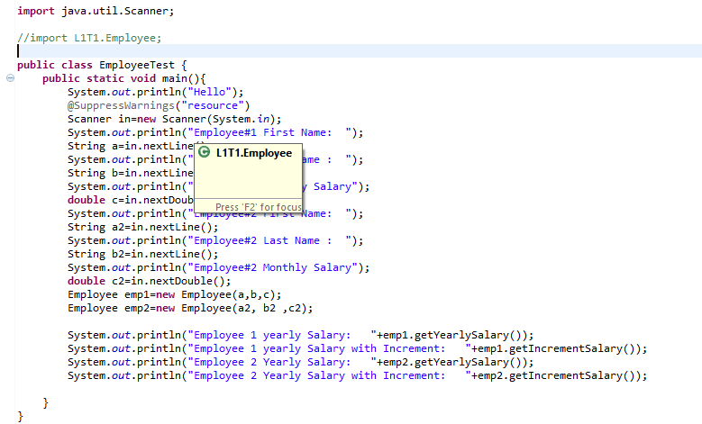

**Output:**

